**ASSIGNMENT-3**

1. write a SQL query to find Employees who have the biggest salary in their Department

Ans.

SELECT max(Employee.salary) , Department.dept_name

from Employee

right outer join Department

on Employee.dept_id = Department.dept_id

group by(Department.dept_name)

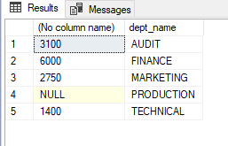

2. write a SQL query to find Departments that have less than 3 people in it

Ans.

SELECT count(Employee.emp_id) AS Number_of_people , Department.dept_name

From Employee

RIGHT JOIN Department

ON Employee.dept_id=Department.dept_id

GROUP BY (Department.dept_name)

HAVING count(Employee.emp_id)<3;

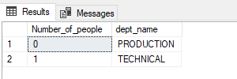

3. write a SQL query to find All Department along with the number of people there

Ans.

select count(b.dept_id) as dept_totalemployee, a.dept_name

from Employee b

right outer join Department a

on a.dept_id = b.dept_id

group by(a.dept_name)

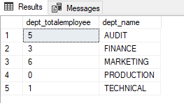

4. write a SQL query to find All Department along with the total salary there

Ans.

SELECT SUM(Employee.salary) AS Salary , Department.dept_name

From Employee

RIGHT JOIN Department

ON Employee.dept_id=Department.dept_id

GROUP BY (Department.dept_name);

